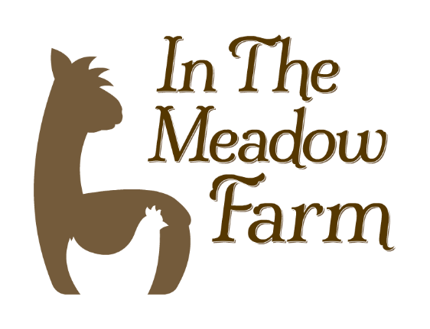
Alpaca My Party
Fun for everyone from 5 to 95

Are you an alpaca enthusiast or know someone who is?
Why not have the perfect party experience!

We offer party opportunities for every age and any occasion- let us help plan your perfect gathering!

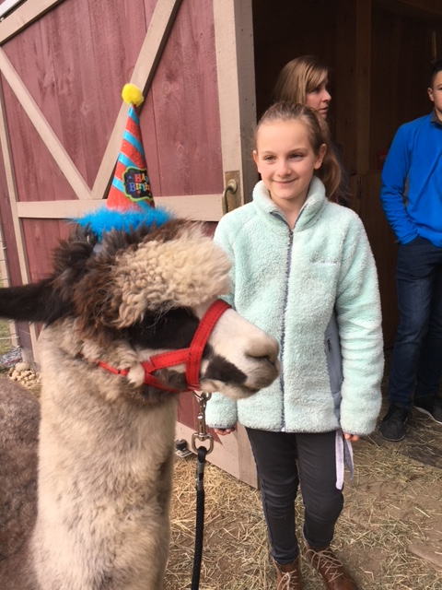
Start with an extended experience in the field with our herd and a BYO Picnic to enjoy in the field or our studio (2 hours) $6 p/p

Add- Ons:
Picnic lunch/supper - approx. 8p/p
(provided by Dragonfly Café)
Felting Class - +$8 to $15 p/p (varies by project)
Campfire S’mores - +$2 p/p
Extra Time? - $2p/p for each hour

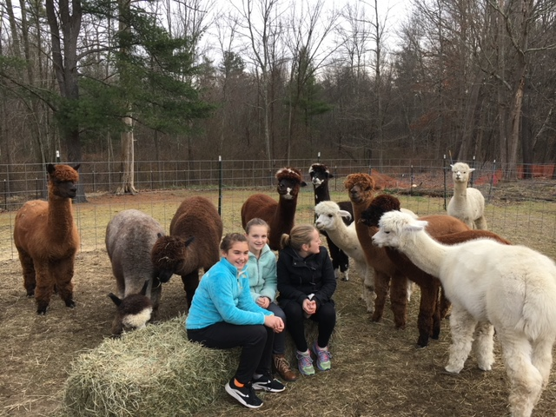
Have your own ideas? We want to hear them! Call or email us today to start planning!
In the Meadow Farm
40 Page Street
Lunenburg, MA 01462
(978) 696-3332
InTheMeadow40@gmail.com
InTheMeadowAlpacas.com

